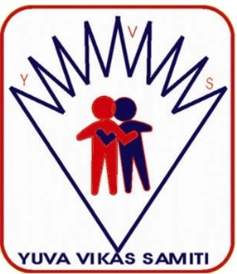
Yuva Vikas Samiti

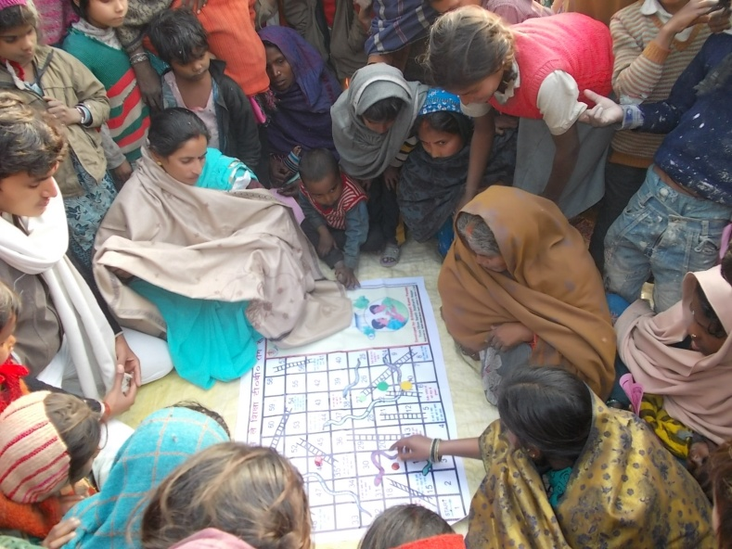

Registered Office
Village- Tharauli, Post- Gaura Upadhyaya
District- Basti (U.P.) 272124
Communication & Administrative Office
Near The Asha Hotel, Mishrauliya, District-Basti 272124
Email: yvsngo@gmail.com Web: www.yvsindia.org
Ph. 9598975008
Main Project Office
376/1 Kajpura, Pidaila, Post- Hajpura, District- Ambedkar Nagar (U.P.) 224186
Project Office
Vill-Sirsiya Tiwari,Post- Bhataura (Santha), District-Santkabir Nagar (U.P.)

About Yuva Vikas Samiti
Yuva Vikas Samiti’(YVS) is primarily involved in availing Skill, Education, Health-care and Nutrition facilities to marginalized Community. Yuva VIkas Samiti is a group of youth of divergent background irrespective of their age, race, class, social status and gender. The group belongs to different regions, and has different skills, talents, and knowledge. How best can we use these creative talents; we will endeavour through various mediums to reach to the unreached. We the youth are convinced of our Indian constitutional values and are committed to constitutional processes.. it was registered as a society in 2007.
Currently, Yuva Vikas Samiti (YVS) is working in 10 districts directly of Eastern Uttar Pradesh and 01 district of Jharkhand for empowering the community, with special focus on issues that affect Youth, women and children.
Yuva Vikas Samiti’(YVS) is primarily involved in availing Skill, Education, Health-care and Nutrition facilities to marginalized Community. Yuva VIkas Samiti is a group of youth of divergent background irrespective of their age, race, class, social status and gender. The group belongs to different regions, and has different skills, talents, and knowledge. How best can we use these creative talents; we will endeavour through various mediums to reach to the unreached. We the youth are convinced of our Indian constitutional values and are committed to constitutional processes. it was registered as a society in 2007.
Currently, Yuva Vikas Samiti (YVS) is working in 10 districts directly of Eastern Uttar Pradesh and 01 district of Jharkhand for empowering the community, with special focus on issues that affect Youth, women and children.

General Information
Name of Org | YUVA VIKAS SAMITI
Name of CEO | Brihaspati Kumar Pandey (Secretary )
Mob. | 9454309514, 9598975008
E-mail | yvsngo@gmail.com
Website | www.yvsindia.org
Facebook Page | @yvsindia
Twitter | @Yuvavikasngo
Legal status of the institution Registration
Society Reg. Act 21, 1860 | 831/2007-2008
Pan No | AAAAY0877A
NGO Darpan Niti Ayog Unique ID | UP/2009/0005790
PFMS ID | UPBS00009535
12 A | AAAAY0877A24LK01
80 G | AAAAY0877A24LK02
CSR-1 | CSR00029819
Certificate of registration under RPwD Act,2016 | 1371/RN/OL/2022-23
National Trust ( Govt. of India)  Certificate of Registration (Under Section 12 (4) of the Act) | UYUV17519438812
Empanelment
SWSM UP Govt. Jal Nigam Grameen | Implementation Support Agency (ISA)
Government of lndia (Ministry of Women and Child Development) (Women Welfare Division) | For conduct capacity building exercises on the Sexual Harassment of Women at Workplace (Prevention, Prohibition and Redressal) Act, 2013-reg.
OFFICE OF DEVELOPMENT COMMISSIONER (HANDICRAFTS) MINISTRY OF TEXTILES, GOVT. OF INDIA | Empanelment No: UP/2009/0005790
Bank Detail
Name and Address of the Bank | Union Bank Of India, 1029 Rameshwarpuri, Main Road Company,Basti
Ac.No. | 215710100026519
IFSC Code | UBIN0821578
MICR

Vision
Self-reliant, equality oriented, full of justice, exploitation free and empowered society

Mission
Empowering the deprived and exploited people of the society, especially for women and children and socially, economically weaker sections, promoting social equality while working for their overall and sustainable development.

Policy applicable in YVS
- H.R. Policy
- Gender policy
- Cash committee ICC Under ( PosH)
- Service regulation
- Disabled policy
- Financial policy
- Account policy
- Audit policy

Our Funding & supporting agencies and departments
Jal Nigam Rural Ambedkar & Balrampur District
State Water & Sanitation Mission ( SWSM) Govt. of Uttar Pradesh
Department of Science & Technology (DST) Govt. of India
Ministry of textiles Govt. of India
National Commission for Women New Delhi
CCRYN ( Ayush Ministry Govt. of India)
National Council for Promotion of Urdu Language (NCPUL) Ministry of Education, Department of Secondary and Higher Education, Government of India.
Ministry of Culture, Government of India
Raja Ram Mohan Roy Library Foundation, Kolkata (Ministry of Culture, Government of India.)
Nehru Yuva Kendra Basti (Government of India, Ministry of Youth Affairs and Sports)
National Book Trust, India (under Ministry of Education, Government of India)
Vishva Yuvak Kendra New Delhi
Indian Development Foundation Mumbai
National Trust : Department of Empowerment of Persons with Disabilities Ministry of Social Justice and Empowerment New Delhi-110075
Akshayashakti Welfare Association Thane
Digital Empowerment Foundation New Delhi
Mamta HIMC New Delh
Lok Mitra Rai Bareli

Network Institution
Stop T.B. Partenership | Geneva, Switzerland | International Level
Children First Network | Lucknow | State Level (U.P.)
White Ribbon Alliance | New Delhi | National Level
State collective for right to education | Lucknow | State Level (U.P.)
Engo network | New Delhi | National Level
Partnership for T.B.care & control india | New Delhi | National Level
Guide Star India | Goregaon (E) | Mumbai | National Level
India Partner Network | India | National Level
VIKASH-SAMUKHYA | India | National Level

Implementing Structure
Management Comitte

Project Director
Project co ordinator

Project manager

Project officer

Block Co-ordinator

Field worker

Community worker
Volunteers

Women Empowerment

Health

Disaster Management
Agriculture
HIV/
AIDS

M.N.H

T.B.
Degital
Empowermenet

Management
Rehabilitate

Livelihood
Micro Finance
Women Right

Adult Education

Priorities Key Issues

Current & Past Project

ISA- Jal Jeevan Misssion-
Yuva VIkas Samiti is working in 2 District ( Ambedkar Nagar & Balrampur ) of Uttar Pradesh as Implementation Support Agency (ISA) under Jal Jeevan Mission (JJM)
The objectives of ISAs are as follows-
- To facilitate constitution of sub-committee of Gram Panchayat, i.e. VWSC and arrange to build capacities of its functionaries;
- To provide handhold Gram Panchayat and VWSC;
- To conduct need assessment of FHTCs and motivate village communities to have FHTCs;
- Act as coordination platform between DWSM and VWSC;
- By using Participatory Rural Appraisal (PRA) tools for community mobilization and carry out need assessment;
- To assist the community in water campaigns initiated by Government of India/ state Government;
- To build awareness on various aspects of water such as rain water harvesting, artificial recharge, water quality, water-borne disease, water saving, water handling, drinking water source augmentation/ sustainability aspects, etc;
- To document and upload success stories from villages;
- To Carry out Social Behavioural Change Communication (SBCC) activities

National Handicrafts Development Programme (NHDP
Yuva Vikas Samiti Run Project The National Handicrafts Development Programme (NHDP) is a government scheme that supports artisans and handicraft clusters. The National Handicrafts Development Programme (NHDP) scheme offers end-to-end support to millions of handicraft artisans. The Pradhan Mantri Vishwakarma Kaushal Samman (PM-VIKAS) scheme will also help artisans improve the quality, scale, and reach of their products.
Popularisation of Science Project
Yuva Vikas Samiti is Oragnized in many Science Mela & Tours Supported by National Council for Science & Technology Communication NCSTC (Department of Science & Technology (DST) Govt. of India) The Project main objective popularize Science & Technology amongst the people of the general and younger generation in particular.
International Women’s Day
Yuva Vikas Samiti is organized different activities on International Women’s Day 2022 supported by Vishwa Yuvak Kendra.
Nanhi Pahal Project
Yuva Vikas Samiti is provided dry ration and sanitary items to specially abled people (PWDs) supported by Vishwa Yuvak Kendram New Delhi under Nanhi Pahal Project .took a step forward in providing alms and support to the specially abled. This relief providing practice will help them overcome the sorrows due to COVID-19. A large population lost livelihood and starved for days and among them were also persons with disability. The project spans in Basti District of Uttar Pradesh and aims to provide relief to the specially abled and help them cope with the pandemic.
Physical Literacy Program
Physical Literacy Program (Conducted the Exposure Visits for around 200 Youths in all the branches of Standard Chartered Bank across Uttar Pradesh with an objective to create an understanding of the Operations of Bank with and ultimately to enhance the financial literacy among the underprivileged population of Youth)
Project SAKSHAM
Yuva Vikas Samiti in association with Indian development foundation is conducting the Financial literacy program In 3 District of Uttar Pradesh. Project SAKSHAM aims to deliver sessions on various essential topics of financial management such as Budgeting, Savings, Investment, and Credit worthiness as these learnings will help students get equipped with the basic financial skills and knowledge required to navigate through this challenging financial world and make sound financial decisions independently. This program is designed to give such a Target Group, the relevant & crisp inputs of how to be self-sufficient with the knowledge of managing their meager finances. Therefore the target group should be women who are in blue-colored jobs and housewives and girl college students who need to be self-sufficient with what ever meager amount that they have or get.
S3 - Sarva Sakhi Swabhiman Project
Yuva Vikas Samiti is Implement is S3 - Sarva Sakhi Swabhiman Project A large section of Youth women in Basti District Supported by Indian Development Foundation both in rural and urban slums need to be educated and empowered. A Youth group of women were presented with tailoring machine and embroidery machine. Now the project has taken good shape and the trained women are able to make products which can help them to generate income for their livelihood. YVS in its next step is going ahead in educating the women in urban slums, particularly parents of the children studying in Bal Gurukuls. The programme is designed to suit the home-makers as it will help them to get acclimatized with their wards education.
Bal Gurukul Project
Yuva Vikas Samiti is Implementing Bal Gurukul Project in 7 District of 2 States Uttar Pradesh and Jharkhand. YVS-IDF Bal Gurukul projects are a success proven sustainable development model. IDF in its diversified objectives has included village development and education programmes into its fold. development. Primary IDF and Blackstone Charitable Foundation supported 06 Bal Gurukuls and RBL bank sanctioned 02 Bal Gurukuls in this financial year.
Project Sui Dhaga Ji
Yuva Vikas Samiti is implement Project SuiDhagaJi in Basti District of Uttar Pradesh is a program designed to empower Youth women through Skill development. The concept here is to provide sewing Machine, and a suitable place, training material and a trainer. The training Centre operates as the basic tailoring learning Centre and also imparts specialized training like embroidery and soft-toy making. The knowledge and the acumen gathered here in this program will further help them to have a productive unit of their own from where they can flourish and grow.
Environmental Programmes
Yuva Vikas Samiti has been working towards raising awareness about environmental issues and protecting the planet through various joint awareness programmes at both institutional and community levels with the active support of corporations, academia, and NGOs. Their tireless efforts aim to educate individuals and communities.
BADHTE KADAM Scheme
Yuva Vikas Samiti Implemented Badhte Kadam Scheme aims at community awareness, sensitization, social integration and mainstreaming of Persons with Disabilities. It has the following objectives:
Raise awareness in the public, regarding Persons with Disability (PwD) covered under the National Trust Act and encourage their inclusion in the society, social integration and participation in all aspects of life.
Disseminate information on preventive strategies for disabilities under the National Trust Act,1999.
Sensitize community stakeholders.
Publicize and maximize benefits of the National Trust schemes PwDs, and families of PwDs.
Increase representation in remote areas and areas where the National Trust is underrepresented.
Spread awareness about myths and misconceptions about disability, disability etiquette, etc.
AkshayaDhaaga Skill Centre
AkshayaDhaaga Skill Centre for a complete tailoring course to support 25 women in a centre. (Course duration 3 months/ 150 hours). Implemented in Five District Supported by Askshaya Shakti Welfare Associatiom Mumbai. Lets together make things great and impact lives. A step towards skilling and creating self-reliance among women.
Akshaya Project
With the help of Mamta Helth Institute Mother & Child New Delhi this project is being operated in district Ambedkar Nagar. The object of this project is to build T.B. Free society.
Qualitaty Basic Education
YVS involved on the effective implementation of the Free and Compulsory Child Education Rights Act, capacity building workshops are organized from time to time with the help of Lokmita Rae Bareli, Basic Education Forum Uttar Pradesh & Scores UP.Under which the capacity building of the school management committees constituted under the supervision of the council schools of primary and junior level has been done, and from time to time the sensitization of public representatives and officials is also done on this issue.
Library Programme
With the help of Uttar Pradesh Pustkalay Prakosth U.P. Govt. and Raja Ram Mohan Rai Pustakalaya Pratisthan Kolkata for framing Literacy and Educational environment in rural areas libraries are being operated.
National Environment Awareness Programme
Operation of Awareness movements is continuing in District Basti with co-operation of Shoharatgarh Environmental Society Siddharth Nagar and ministry of Environment and forest Govt. of India.

